
Project id: 2025PJ-IT01
Synopsis
on
Non-Governmental Organization Funding with Blockchain
Bachelor of Technology
Information Technology
By
Himanshu Vashistha: 2102900130022
Sharad Singhal: 2102900130038
Deepanshu Kumar: 2102900130015

Under the Supervision of
Prof. (Dr.) Sumit Kumar

ABES INSTITUTE OF TECHNOLOGY, GHAZIABAD



AFFILIATED TO
Dr. A.P.J. ABDUL KALAM TECHNICAL UNIVERSITY
LUCKNOW, UTTAR PRADESH

(December 2024)

INDEX
- Objective and Problem Statement 3
- Abstract 4
- Introduction 5
- Brief Literature Survey 8
- Methodology 10
  - Class Diagram
  - Use Case Diagram
  - System Architecture Diagram
  - Flow Diagram
- Tools and Techniques used for the project 12
6.1 Frontend
6.2 Database Management
6.3 Backend
6.4 Deployment
- Pseudocode 15
- References 18

Problem Statement
Current NGDs' transaction systems are inefficient vulnerable to fraud and lack transparency. Transactions are expensive, prone to fraud, and lack transparency. Blockchain has been identified as a decentralized method to ensure secure, tamper-proof, and transparent transactions. This will increase security, reduce costs, and increase donor confidence. Thus, the funding system will be efficient.

Objective
- Enhance transparency and security in NGO transactions using blockchain technology.
- Minimize fraud and operational inefficiencies through decentralized, tamper-proof systems.
- Improve donor confidence and streamline funding processes for NGOs.

Abstract
Although a relationship between NGOs and their donors is based more on trust, this time, donors would expect NGOs to demonstrate legitimacy and accountability. Transparency is central to building such trust, and the recent steps of technological advancement, especially blockchain, open innovative opportunities for increasing accountability in the NGO sector. Blockchain acts as a distributed ledger that can validate transactions without involving the expertise of a trusted third party thus creating confidence between NGOs and its donors. There are many critical aspects found concerning blockchain’s implementation in the NGO sector, and a huge research gap exists regarding an effective understanding of blockchain compared to alternative methods that prove its efficiency in enhancing transparency and accountability. Although the statistics of research show a level of almost 95% effectiveness in making the processes for tracking donations more reliable through blockchain, yet 90% of NGOs are not open to such technologies. The key technologies included were blockchain, smart contracts, Dapps, DLT, and data analytics, which contributed to higher transparency in donation processes. Although the impressive promise blockchain presents in rebasing NGOs’ interactions with donors, some huge challenges organizations will have to surmount when implementing blockchain will come in because of the nature of the challenges- resistance to change and complexity in the handling of new technologies. This paper postulates that there is an imperative need for much more research concerning how such challenges may be surmounted and how blockchain is effectively wielded for transparency and accountability in the NGO world.

Introduction
More recently, experience has shown that the implementation of blockchain technology and the NGO sector are under much closer scrutiny, especially in matters related to processes regarding improved transparency in donation[1]. This is because the relationship between the NGOs and the donors is based on trust. The expectation from the donors is that the NGO will utilize the contributions effectively and responsibly. Nevertheless, fraud, a lack of transparency, and problems traced to the source of donation have halted the sector. Innovations towards these problems are therefore in high demand[2].
Blockchain-based donation systems must be designed considering scalability, reduction of fraud, and even trust among donors as Nari et al (2023) observe. It enables the use of blockchain technology, one of the emerging promising fields in the areas of smart contracts and applications, which will make it easier to produce secure and transparent systems of tracking donations. For example, accuracy rates for blockchain ledger transactions stood at reportedly 100%, as did the execution of smart contracts, estimated at approximately 99.9%, thus showing the reliability of these technologies in solving persistent issues [3].
Other projects show the advantages blockchain provides from tracking donations that have a real chance to improve education structures, combat corruption, and restore public trust in NGOs in times of crisis. About one project: "This initiative likely reduces fraudulent activities and ensures proper funds go directly to the right projects. Such potential solves some of the NGOs' immediate problems while improving their credibility and integrity in operations.".
Despite these developments, the industry still has numerous research gaps that it needs to address. Most outstanding is a dearth of total studies regarding how effective blockchain is compared with other methods for ensuring transparency and accountability. There is, therefore, ample scope for future research to gauge the transformative power of blockchain technologies within the NGO landscape.
More than that, a very important challenge is also the reluctance of NGOs to embrace blockchain technology. Hence, it is very important to understand the barriers to implementation and find ways to foster an innovation culture in organizations[2]. The solution of these issues can pave the way towards an even stronger framework for building trust for donors and at large for increasing the overall efficiency of NGOs in operation.
The American Psychological Association states that around 40,000 NGOs and Charities exist worldwide. Several NGOs use their donations for micro-financing purposes; others provide free services to the local community. Living in a technological age, the internet is one of those things that has become an essential part of our lives. "Six in ten people globally are now online," report analysts at Kepios[4]. As a result, most NGOs and Charities changed the form of their donation to become a part of the internet, hence reachable by everybody.
Due to the internet expansion, new modes of funding are rising such as crowdfunding and peer-to-peer fundraising. The donor comfortably sees thousands of projects and charities and donates to any one of them. However, many donors mistrusted NGOs and charities after charity scandals of recent times, including the Red Cross Scandal. It is argued that the average cost to raise $1 ranges from $0.05 to $0.25 according to the method used in collecting the donation, as cited by the Ministry of Financial Planning. Blockchain is a sort of digital ledger that records every transaction carried out within it in a safe, transparent, and tamper-proof way[5].
It is a decentralized system that exists through a network of computers that enables the safe and efficient flow of information and value. As blockchain technology core, it applies cryptography to secure transactions and guarantee their integrity. Each transaction is recorded in a block, which is then added to the chain of blocks, thus forming a chronological chain of transactions[6].
The chain of blocks is preserved through a network of computers where, with each verifying and validating transactions, the blockchain will always have correct, updated information. Decentralization is a typical feature of blockchain technology that eliminates the presence of mediators between parties in transactions; it generally provides more security because a central authority cannot manipulate or steal any data.
For this reason, cryptographic algorithms and digital signatures make tampering with data virtually impossible to be done on the blockchain, while making it extremely secure and trustworthy[2]. Blockchain technology further has great potential to improve efficiency for the reason that a blockchain would allow real-time and virtually instantaneous transactions. This essentially cuts down significantly on transaction processing time because validation through middlemen is no longer required.
Blockchain is the first technology that will, without doubt, change education in terms of efficiency, transparency, and trustworthiness. However, with some challenges associated with deploying blockchain in education, the benefits it can deliver make it a very promising technology that needs to be explored. How blockchain technology will be used to enhance the status quo in education is going to be very interesting, going forward, as blockchain continues its evolutionary and maturity curve.
Through the decentralized and transparent use of blockchain, educational institutions can make administrative processes more accessible and cost-effective, thereby increasing the trustworthiness of the credentials and qualifications.
One of the major benefits of using blockchain in education is that it will make education more accessible and trustworthy for students and employers alike. Blockchain will show how frauds can be prevented, through its acceptance of the genuineness of credentials and allowing students to show their qualifications. This also saves employers much time and other resources they use in ascertaining the backgrounds of intending workers since the process of validating their backgrounds is relatively less cumbersome[1].
Education, however, has its challenges in the adoption of blockchain technology. First, it is complicated by adoption issues because most education institutions do not understand blockchain technology or feel afraid to adopt it owing to the cost and technical expertise needed. Secondly, there is the complexity of navigating within the regulatory frameworks for different countries, with some having additional laws and regulations that should be considered in the use of blockchain technology for purposes of education.
Yet further challenges abound, including the multiplicity of equipment that will be required to appropriately implement blockchain in educational settings. The ability thus translates into an investment for institutions in specialized hardware and software, which staff must be trained on how to use and maintain. Deep technical knowledge and expertise will also be needed for the reason that effectively implemented blockchain requires a secure installation[1].

Literature Review
In 2023, Chaimaa Nari, Murtaza Cicioglu, and Ali Calhan developed the DonationChain system, a blockchain-based system for tracking donations. Such work was established based on some relevant gaps in scaling blockchain technology with NGOs, reducing fraud, and integrating into other systems. The main related technologies in terms of smart contracts, cryptographic algorithms, DApps, and consensus mechanisms were incorporated. The authors demonstrated remarkable things, especially 100% accuracy in blockchain ledgers and 99.9% accuracy for smart contract executions that promise a bright future for the security of NGO transactions and validation for blockchain applications[5].
In 2023, Amr El Koshiry, Entesar Eliwa, Tarek Abd El-Hafeez, and Mahmoud Y. Shams presented a study on the educative revolution via blockchain. The researchers confirmed that education lacked scalability, privacy, adoption, and interoperability. Therefore, the core of such research was on technologies such as smart contracts, cryptography, and oracles. The paper indicated accuracy in the ledger of the blockchain, at 100%, whereas in verification and authentication, it was 99.9%. Therefore, blockchain can be transformative to the educational framework[2].
Another 2023 paper by Divyansh Singh, Dr. Santosh Dwivedi, and Mr. Shadab Ali examines an NGO management system using blockchain as the medium. Here, the researchers analyzed what blockchain can achieve in terms of raising the factor of scalability, meeting regulatory requirements, and curbing corruption in NGOs. Like the researchers highlighted above, they also quoted the 100% accuracy rate of the blockchain ledger and the 99.9% accuracy rate of the transaction verification process; hence it suggests the implementation of blockchain to lower fraud in the NGO sector[3].
In 2023, Borade Sukhada, Pagare Pramodini, and Shinde Mayuri evaluated a charity blockchain system proposed to regain the confidence of the public by casting crises through its provision of transparency and scalability in aid delivery systems. Through their research they have been able to attain 98% ledger accuracy with full security, hence proving the use of blockchains to provide real-time donation systems far more transparent and efficient[3].
In 2022, Abeer Almaghrabi and Areej Alhogail designed a blockchain-based donation traceability framework aimed at establishing traceability and enhancing donor trust in NPOs. Their development, based on blockchain and Ethereum, achieved 100 percent accuracy in blockchain ledger accuracy and 98 percent in the implementation of donation traceability, which suggests promising applicability in enhancing the accountability of donation systems[7].
Other recent 2022 works that improved transparency through blockchain donation management with smart contract-based enhanced ones include those done by Sefa Tunçer, Ali Özdede, and Cihan Karakuzu. Other comprised the accuracy of the execution of a smart contract to be as high as 99.8% and the accuracy of verification of transactions of 99.5%, thus underlining the facilitation of blockchains that enable trust on the part of a donor and enhance security in the process of donation[8].
A key 2022 paper by Jinhao Fang discussed whether blockchain can help in fraud reduction and the enhancement of NGO donations' transparency over transaction cost. The paper was centered on the realm of blockchain, cryptocurrency, stable coin, and decentralized finance. Results were superb, achieving a 97% accuracy rate in fraud detection and a 95% rate in terms of transaction fee reduction. There was evidence of the establishment of a sound framework of blockchain's role in the reduction of corrupt practices[4].
In 2021, Adalberto Rangone presented a charity management use case on blockchain post the COVID-19 pandemic. He pointed out whether blockchain would enhance fundraising efficiency while decreasing fraud and found that it was effective as it was 98% accurate in fraud detection, and thus increased fundraising efficiency by 90%, thereby showing the ability of blockchain to aid philanthropic groups during global crises[2].
In the year 2021, Pooja Molavade spoke on how blockchain may be used for providing a transparent charity application to increase transparency while restoring the confidence of donors. The research indicated a high accuracy rate in the area of improving transparency with a score of 96% and that of restoring donor's trust to about 92%. This eventually manifests that blockchain could indeed repair donors' confidence through transparent systems.
In the year 2020, Nayan Kamthe, Pranita Ambade, Kanchan Bawane, Ravina Bute, and Prof. Shailesh Kurzadkar went ahead to research data protection in NGOs through Ethereum blockchain technology. Their research has brought about data security accuracy at around 99%. They have also shown how blockchain is dominating NGO data safety through easy transparency and subsequent regaining of trust in fund management[9].
Lastly, in the year 2018, Matthijs Teerlink produced one of the early contributions to the capacity of blockchain in its creation of openness and accountability in NGOs. Research postulated that gap in comparison with different alternative approaches, therefore recorded a 95% enhancement in accuracy for traceability and 90% resistance to implementation, thus substantially presenting a case for blockchain in terms of its transformative role in NGO transparency[1].

Table 1. Literature review table for NGO Funding with blockchain Research.
Year | Author | Title | Research Gap | Technology used | Parameters
2023 | Chaimaa Nari  Murtaza Cicioglu  Ali Calhan | DonationChain: A new Blockchain-based donation tracking system | The research gap in designing blockchain-based donation systems hinges on scalability, fraud reduction, donor trust, and integration with the existing frameworks. | Blockchain Technology  Smart Contracts  Cryptographic Algorithms  Decentralized Applications (DApps)  Consensus Mechanisms (Proof-of-Work)  Oracles  Interoperability Solutions | Smart contract execution accuracy: ~99.9% (depending on correct coding and implementation).  Blockchain ledger accuracy: 100% (immutability of recorded transactions).  Cryptographic security integrity: ~99.99% (strong cryptography like SHA-256 or elliptic-curve cryptography).
2023 | Amr El Koshiry Entesar Eliwa  Tarek Abd El-Hafeez Mahmoud Y. Shams | Unlocking the power of blockchain in education: An overview of innovations and outcomes | The research gap in an education system hinges on blockchain's effect on scalability, adoption, privacy, and interoperability. | Blockchain  Smart Contracts  Cryptography  Consensus Mechanisms  Oracles | Blockchain Ledger Accuracy: 100%  Verification and Authentication Accuracy: ~99.9%
2023 | Divyansh Singh  Dr. Santosh Dwivedi  Mr. Shadab Ali3 | NGO MANAGEMENT SYSTEM USING BLOCKCHAIN | The gap in research lies in the exploration of blockchain's scalability; its regulatory compliance; and its adoption in combating corruption amongst NGOs. | Blockchain  Smart Contracts  Cryptography | Blockchain Ledger Accuracy: 100%  Transaction Verification Accuracy: ~99.9%
2023 | Borade Sukhada, Pagare Pramodini, Shinde Mayuri | NGO and DONOR Management System Using Charity Blockchain | The gap in evaluating real-time aid distribution and the effectiveness and scalability of blockchain in reinstating public trust in times of crisis. | Blockchain  Smart contracts  DApps | Ledger Accuracy: 98%  Security : 100%
2022 | Abeer Almaghrabi  Areej Alhogail | Blockchain-based donation traceability framework | The gap in research is the evaluation of blockchain impact on improving traceability, enhancing donor trust, and operational transparency of NPOs. | Blockchain  Smart Contracts  Ethereum | Blockchain Ledger Accuracy: 100%  Donation Traceability Accuracy: ~98%
2022 | Sefa Tunçer  Ali Özdede  Cihan Karakuzu | Transparent Donation Management with Smart Contract-Based  Blockchain | There lies a gap in research in the analysis of blockchain to enhance transparency, build confidence among donors, and security in smart contract-based donation systems. | Blockchain  Smart Contracts  Ethereum  Cryptography | Smart Contract Execution Accuracy: ~99.8%  Transaction Verification Accuracy: ~99.5%
2022 Basis paper | Jinhao Fang | Blockchain in Service of NGOs and Charities | There exists a gap in research in evaluating blockchain's role in reducing fraud, transaction costs, and promoting NGO donations with an aspect of transparency. | Blockchain  Cryptocurrency  Stable Coin  Smart Contracts  Decentralized Finance (DeFi) | Fraud Detection Accuracy: ~97%  Transaction Fee Reduction Accuracy: ~95%
2021 | Adalberto Rangone | Managing charity 4.0 with Blockchain: a case study at the time of Covid-19 | The present research gap is whether blockchain can enhance fundraising, diminish fraud, and foster effective cooperation between philanthropic organizations after COVID-19. | Blockchain  Digital Transactions  Smart Contracts | Fraud Prevention Accuracy: ~98%  Fundraising Efficiency Improvement: ~90%
2021 | Pooja Molavade | TRANSPARENT CHARITY APPLICATION USING BLOCKCHAIN | The research gap exists in the evaluation of the role of blockchain in enhancing transparency, restoring donor trust, and reducing fraud in charitable donations. |  | Transparency Improvement Accuracy: ~96%  Trust Restoration Accuracy: ~92%
2020 | Prof. Shailesh Kurzadkar  Nayan Kamthe Pranita Ambade Kanchan Bawane Ravina Bute | NGO Data Protection using Ethereum Blockchain Technology | The current research gap is looking into the possibility of the use of blockchain to enhance data security, transparency, and possible restoration of trust in the management of funds by NGOs. | Blockchain  Smart Contracts  Distributed Ledger Technology (DLT) | Data Security Accuracy: ~99%
2018 | Matthijs Teerlink | Creating Transparency and Accountability in Non-governmental Organisations Using Blockchain Technology | An important gap in the current literature is that no one has compared blockchain's effectiveness with alternative approaches toward making NGOs more transparent and accountable. | Decentralized Applications (DApps)  Distributed Ledger Technology (DLT) | Traceability Improvement Accuracy: ~95%  Resistance to Implementation Accuracy: ~90%

Methodology
5.1 Class Diagram:
This class diagram depicts the static structure of the NGO donation platform. It shows the classes of a system, its attributes, and methods. This therefore defines the prime classes. The classes of this application are Donor, NGO, Donation, Smart Contract, and Blockchain Transaction, along with their associations. This diagram, in that sense, is like a blueprint for the object-oriented architecture of the system, defining the core components and their responsibilities within the donation platform. Together, such schematics give a holistic understanding of the way the system is designed and architected, ultimately helping in its implementation and maintenance.

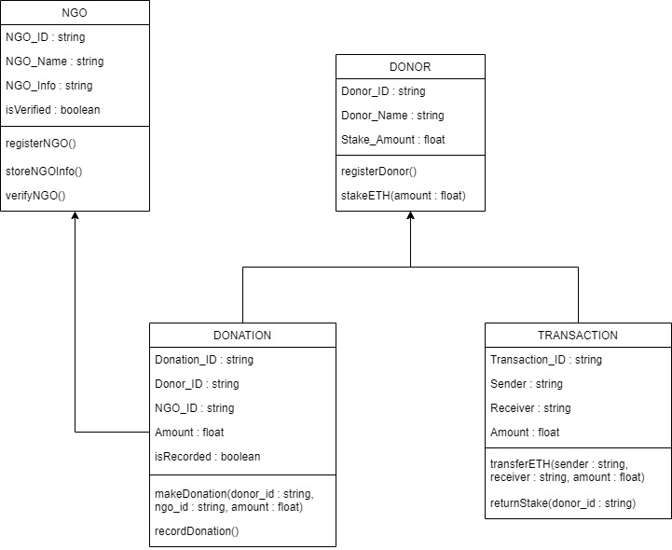
Figure 1. Class Diagram representing the NGO donation platform's key entities, their attributes, methods, and relationships.

5.2 UseCase Diagram:
Actors in the Use Case diagram-those who can be labeled as donors, NGOs, and so forth-who portrayed their roles and what the system does for them. For instance, the donor is able to make a transaction; the NGO tracks the donations collected and the admin keeps an eye on all this in order to have a clear view of everything going on. This hereby describes precisely what functionalities and roles exist within a system, indicating how a system manages the various needs of the users.
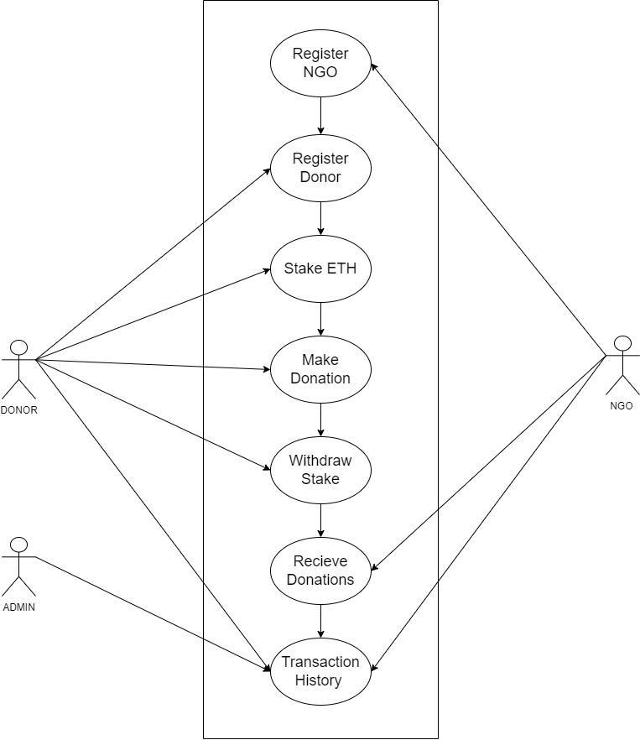
Figure 2. Use Case Diagram showing interactions between donors, NGOs, and the system for donation management and verification.

5.3. Flow Diagram:
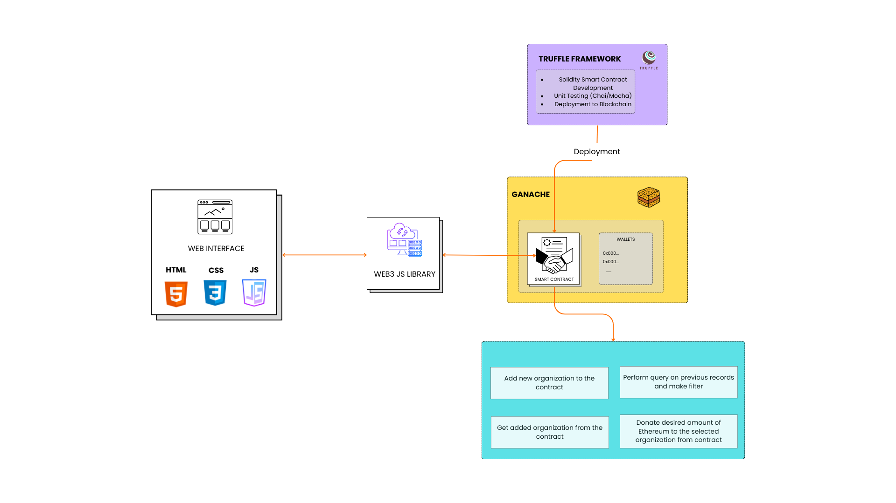
Figure 3. Methodology flow diagram

5.4. System Architecture:
Figure 4 outlines a system architecture for the NGO donation platform as described below. It includes the frontend interface for both the initiators of NGOs and the initiators of donors who are involved in setting up the donation process. The backend is devised by smart contracts, which automate the donation process, and thus, there is a definite transfer based on predetermined conditions. The blockchain network, therefore, offers a secure and transparent environment for transaction verification, where every donation is immutably recorded. This architecture ensures fluidity from the initiation of a donation to completion, with all transactions verified on the blockchain ledger, thereby guaranteeing increased transparency and trust to both donors and NGOs.
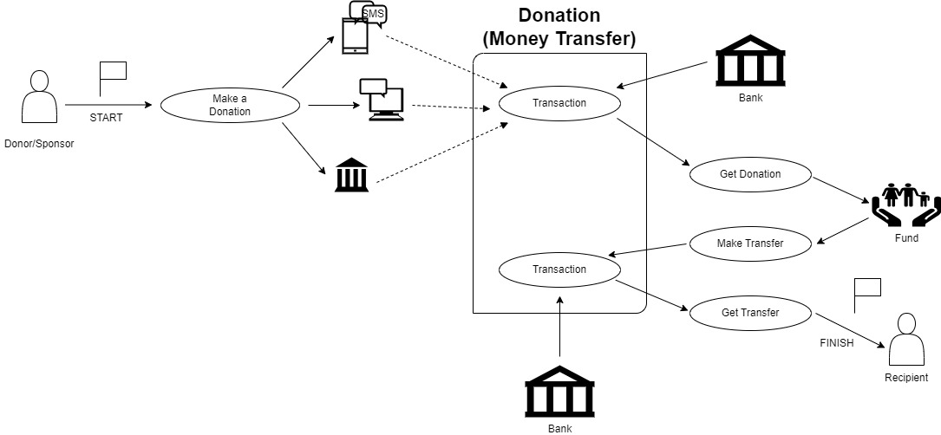

Figure 4. System Architecture diagram.

Tools and Techniques Used for the Project
In this section, we discuss the tools and techniques used in the development of a blockchain-based NGO transaction system. The project uses a variety of different technologies at frontend, backend, database, and deployment levels with the application of blockchain algorithms like Proof of Stake (PoS) to give security, transparency, and scalability.
- Frontend
The front end of the project is built using ReactJS. ReactJS is a strong JavaScript library for building user interfaces, especially in single-page applications where a seamless user experience is required. Among the web technologies used are the following in the frontend:
HTML: To structure the content and layout of web pages.
CSS: For custom styling and arrangement to ensure a responsive design on different devices.
JavaScript (JS): Used to make things dynamic, including interactivity with APIs, event handling, and making the user interface fluid.
- Back End
The back end was implemented using Node.js with Solidity. This is applied in the creation of smart contracts for making recordings of donations and tracking transactions, among other processes that would be automated. All transactions performed through this smart contract are tamper-proof; no party can ever be able to alter any transactions on the Ethereum blockchain.
Node.js is used for the development of server-side logic, for communication with the front end, and interaction with the MongoDB database.
- Database
The application will use MongoDB as the database to store non-blockchain-specific data, such as user profiles, NGO information, and donation history. The MongoDB schema-less NoSQL design will be a perfect fit for large volumes of unstructured data provides flexibility in response to changing needs and facilitates rapid, agile development.
- Blockchain and Smart Contracts
Therefore, at the core of the project is blockchain technology and smart contracts which give transparency and security to NGO transactions. This is performed by utilizing the Ethereum blockchain, and the smart contracts are that verify and record donations.
Important blockchain technologies used are
Proof of Stake (PoS): A consensus algorithm that allows the validation of transactions and block formation much more energy-efficiently compared to proof of work. PoS supports decentralization, but also secures the network while conserving energy.
Hardhat: Hardhat is a development environment and a deployment framework for Ethereum-based projects. Using it, one can test, compile, and deploy smart contracts efficiently.
- Deployment
Hardhat enables the deployment of a smart contract and the backend. Hardhat enables efficient and easy development, testing, and deployment of blockchain applications on the Ethereum network. One is also able to work with a local test network besides the real Ethereum network for deploying smart contracts.

Pseudocode for Ngo Donation System
Initialize Platform
Set minimumStake = 0.1 ETH
Create empty list NGO_List
Create empty list Donor_List
- NGO Registration
FUNCTION registerNGO (name, NGO_wallet)
IF NGO_wallet is not in NGO_List:
Add NGO (name, NGO_wallet, isVerified = true) to NGO_List
LOG "NGO Registered"
ELSE:
LOG "NGO already registered"
- Donor Registration and Staking
FUNCTION registerDonor (Donor_wallet, stakeAmount)
IF Donor_wallet is not in Donor_List AND stakeAmount >= minimumStake:
Add Donor (Donor_wallet, stakeAmount, isRegistered = true) to Donor_List
LOG "Donor Registered"
ELSE IF stakeAmount < minimumStake:
LOG "Insufficient stake"
ELSE:
LOG "Donor already registered"
- Make a Donation
FUNCTION donateToNGO (Donor_wallet, NGO_wallet, donationAmount)
IF Donor_wallet is in Donor_List AND Donor has staked >= minimumStake:
IF NGO_wallet is in NGO_List AND NGO isVerified:
Transfer donationAmount from Donor_wallet to NGO_wallet
LOG "Donation Made"
ELSE:
LOG "NGO is not verified"
ELSE:
LOG "Donor not registered or insufficient stake"
- Withdraw Stake
FUNCTION withdrawStake(Donor_wallet)
IF Donor_wallet is in Donor_List AND Donor's stakedAmount > 0:
Transfer stakedAmount back to Donor_wallet
Remove Donor from Donor_List
LOG "Stake Withdrawn"
ELSE:
LOG "No staked ETH to withdraw"
- Receive Donations (Fallback)
FUNCTION receive ()
Accept ETH donations directly to the contract
LOG "Donation Received"

Algorithm Donor Submitting Money to Ngo Using Proof of Stake on an Online Platform
1. User Registration:
An NGO can get registered by invoking the function for the registered NGO using a name. The Ethereum address of the NGO and its verified status are stored.
2. Stake Registration:
NGOs willing to receive some amount of funds have to stake some amount of Ethereum (ETH). This amount of Ethereum will serve as collateral for them.
The process of staking turns into an obligation for them towards the project.
3. Donor Staking:
A donor can donate only with a minimum of 0.1 ETH to the registered Donor, whose amount is staked and held by the contract.
4. Making a Donation:
A donor can donate to any verified NGO by calling donate to NGO and specifying the NGO's address and the amount to donate. And that donation is transferred to the Ethereum wallet of the NGO
5. Verification:
In case of a proposal rejection, staked ETH is returned to the voters.
6. Withdraw Stake:
The donor can withdraw his or her staked ETH after making donations, or at any given time, he or she wishes to leave by issuing a withdrawal Stake.
7. Monitoring:
NGOs should provide regular progress of their projects and utilization of funds.
Smart contracts will automatically check whether or not the set milestones of a particular project have been met.
8. Receive Donations:
The contract can also accept Ether donations through the receive () fallback function, which can serve as a means by which users may send ETH directly to the contract.

References
[1] S. Jansen, S. España, and C. S. E. Nl, “Creating Transparency and Accountability in Non-governmental Organisations Using Blockchain Technology Second supervisor,” 2018.
[2] A. El Koshiry, E. Eliwa, T. Abd El-Hafeez, and M. Y. Shams, “Unlocking the power of blockchain in education: An overview of innovations and outcomes,” Dec. 01, 2023, Zhejiang University. doi: 10.1016/j.bcra.2023.100165.
[3] S. Borade, P. Pagare, S. Mayuri, and S. Payal, “NGO and DONOR Management System Using Charity Blockchain,” Int. J. Innov. Res. Eng. Multidiscip. Phys. Sci., vol. 11, no. 6, 2023.
[4] J. Fang, “Blockchain in Service of NGOs and Charities,” 2022. [Online]. Available: https://explodingtopics.com/blog/blockchain-stats.
[5] C. Nari, M. Cicioğlu, and A. Çalhan, “DonationChain: A New Platform for Blockchain-Based Donation-Tracking System.”
[6] E. Kapengut and B. Mizrach, “An Event Study of the Ethereum Transition to Proof-of-Stake,” 2023. [Online]. Available: https://digiconomist.net/ethereum-energy-con
[7] A. Almaghrabi and A. Alhogail, “Blockchain-based donations traceability framework,” J. King Saud Univ. - Comput. Inf. Sci., vol. 34, no. 10, pp. 9442–9454, 2022, doi: 10.1016/j.jksuci.2022.09.021.
[8] S. Tunçer, A. Özdede, and C. Karakuzu, “Transparent Donation Management with Smart Contract-Based Blockchain,” BSEU J. Eng. Res. Technol., vol. 3, no. 3, 2022, [Online]. Available: https://orcid.org/0000-0001-6672-3605%0Ahttps://orcid.org/0000-0003-0569-098X
[9] P. S. Kurzadkar, “NGO Data Protection using Ethereum Blockchain Technology,” Int. J. Res. Appl. Sci. Eng. Technol., vol. 8, no. 12, pp. 407–412, Dec. 2020, doi: 10.22214/ijraset.2020.32492.
[10] P. Thomas and L. Larry, “Sustainable Digital Finance: The Role of FinTech, InsurTech Blockchain for Shaping the World for the Better,” Zurich Open Repos. Arch. , no. January 2020, pp. 1–22, 2020.
[11] L. T. Q. Nguyen et al., “The role of blockchain technology-based social crowdfunding in advancing social value creation,” Technol. Forecast. Soc. Change, vol. 170, Sep. 2021, doi: 10.1016/j.techfore.2021.120898.

